
TALISKA QEYBTA BOOLISKA GOBOLKA JUBADA HOOSE EE DOWLAD GOBALEEDKA JUBALAND EE SOMAALIYA
THE POLICE HEAD QUARTER FOR THE LOWER JUBA OF JUBALAND STATE OF SOMALIA

HOGAANKA BAARISTA DAMBIYADA CID Criminal Investigation Directorate of Jubaland Police
REF: JPFHQ/CID/NC:2002/2026 Date: 14/Jan/2026
WARQADA DAMBI LA’AANTA NON-CRIMINAL CERTIFICATE
TO WHOM IT MAY CONCERN:
BAHJO WARSAME YUSUF
Magaca/name:
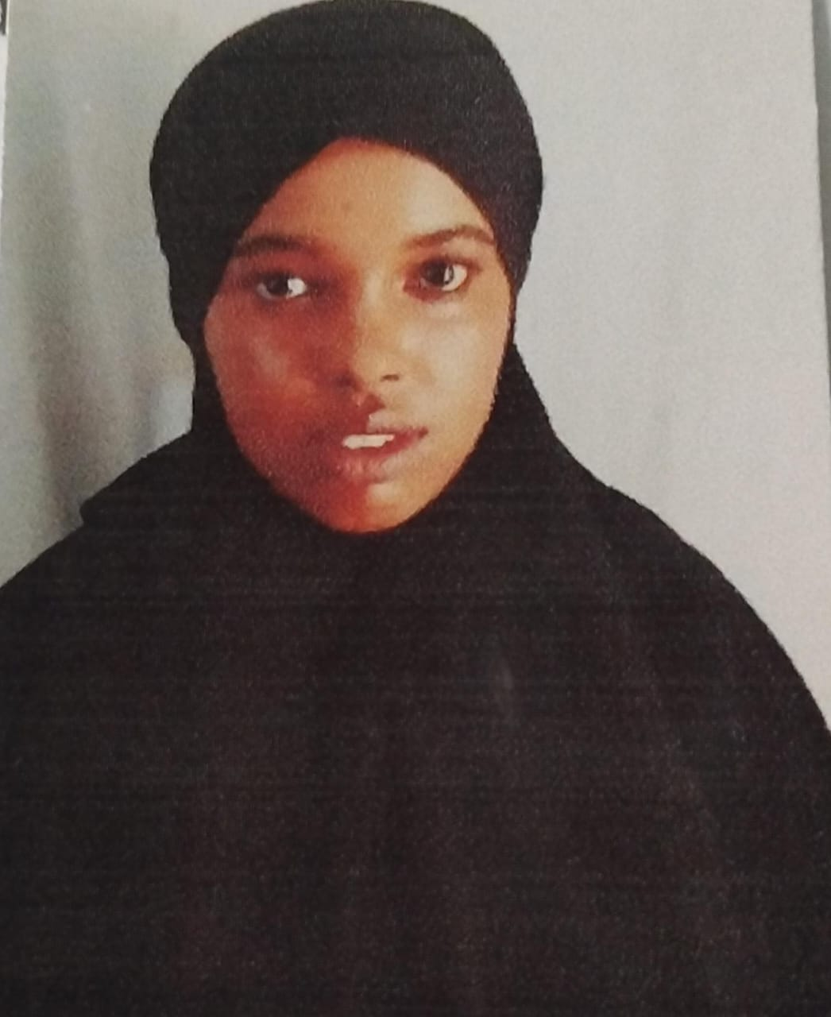

MUHUBO HARED ALI
Magaca hooyada/ mothers name:
FEMALE Jinsi/ gender:
Ref:JPHQ/CID/NC/2002
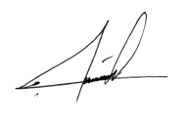
17th Feb 2009 Taarikhda dhalasha / date of birth:
KISMAIO, SOMALIA
Goobta dhalashada/ place of birth:
This is to certify that Sahra Abdisalan Hussein born on 25th November, 1998 in Kismaio, Somalia has no criminal record registered in the records of the Criminal Investigation directorate of Jubaland Police.
Sahra Abdisalan Hussein has undergone a comprehensive background check and has been found to have no criminal history within the jurisdiction of Jubaland State.
This certificate is issued upon the request of Sahra Abdisalan Hussein for international purposes, such as visa application, education, or other official needs is valid for a period of 6 months from the date of issue.
Director of Criminal Investigation Directorate

Cap: Omar Hujale Abdi
  - Signature:……………………..

